

**VOICE BASED HOME AUTOMATION**

Batch No: 180065

**Guided by**

**Prof.M.Kalyan chakravarthi**

**Dept. of ECE**

**K.Raja manohar[17BCD7053]**

**ABSTRACT**:

Home automation is commonly called smart home . It involves the control and handle the things like light, fan, door, alarming for certain remainders, security purposes etc. All the things are connected to the internet and all of them can accessed at any place and any time.

Smart homes refers to energy efficient, time

saving includes reduces the human efforts. Commercial

content distribution network (CDNs) has Video-on-demand

(VOD) services for on-demand capacity provisioning on

smart television (Home Automation). The content has full

control and customization, so they prefer self- managed

content infrastructure. The initial capital investment for

physical infrastructure was so expensive and quite difficult

for management. The objective of key providers was to

reduce the server rental cost by accessing through the

efficient and inexpensive ESP8266 chip to the cloud

platforms on which dynamic server provisioning to reduce

the server rental cost which was the key objective for

content providers.

In this paper we addressed the

challenges of reducing the cost of accessing the cloud

platforms. We present the construction of ESP8266 with the

microcontroller are attached to get the smart access to all the electronic devices . Here in this project we are using syndric service of amazon through which we connect to amazon echo dot and node mcu .

**INDEX**

**1.     Introduction**

**2.     Problem Definition**

**3.     Objective**

**4.    Methodology/Procedure**

**5.    Results and Discussion**

**6.    Conclusion and Future Scope**

**7.    References**

**8.    Codes in Appendix**

**INTRODUCTION:**

This project involves the control and handle the things like light, fan, door, alarming for certain remainders, security purposes etc. All the things are connected to the internet and all of them can accessed at any place and any time. The web server is simultaneously updated by sensing the status of the things which are connected to the network. The status of the appliances is controlled by the switch it either ON or OFF using the computer technology.

It also provides the security, energy efficient, and ease of use, hence it is adopted more. It also helps by providing to control and monitoring on web browser.The main objective of the project is to help handicapped people and aged people by alerting in the critical situations.

All the devices can be used in our own sitting place

itself.

**PROBLEM DEFINITION:**

This module will not work if the wifi connection is slow or lost

**OBJECTIVE:**

Home automation deals with providing a network in the house which links computers & peripheral equipment. Smart chip bearing household appliances (white goods) e.g. dish washers, washing machines, microwaves etc., and sub-systems like Heating, Ventilation, Airconditioning (HVAC), and security systems.

The way of this concept function is when a user speaks out some command, then the voice is captured through ALEXA echo dot as the input device. Once the voice is captured, the usage of a decoding system that will convert the analog (voice) to digital (binary signal). Later, the input voice is compared with the data stored in the memory early before the testing. The output of the comparison is the voice matched with any of the command trained and certain signal is produce as the input for the controlling system.

**ADVANTAGES:**

1.Flexibility & Convenience

2.Security

3.Cost Saving

4.Security

5.Remote Control

The applications are limited only by your imagination:

♦ Turning lights down / off at night.

♦ Operating outside lights

♦ Turning lights or radio on / off when someone approaches the house, simulating occupancy

♦ Operating television, hot water heater, kettle, toaster etc. ready for your use.

♦ Optimizing use of low cost electricity.

♦ Working with intelligent electrical white goods e.g. washing machine, fridge, microwave etc.

**METHODOLOGY:**

The status of the appliances is controlled by the switch it either ON or OFF using the computer technology.

* **1.ALEXA :**

Alexa is capable of voice interaction , music playback , making to do lists , setting alarms , streaming podcasts , providing weather updates , and other real time info . It can also control some smart devices using itself as a home automation hub . We will use ECHO DOT in tis project that allows users to activate the device using a wake word such as ALEXA or COMPUTER as in startrel .In the home automation space , alexa can interact with several different devices **.**

**2.MODULE IDENTIFICATION:**

The ESP8266 Wi-Fi Module is a SOC with integrated TCP/IP protocol stack which allows any microcontroller to access Wi-Fi network. ESP8266 module is pre-programmed with an AT command set firmware. It can host an application of all Wi-Fi networking functions from another application processor. This module has storage capability and a powerful on-board processing that allows integration of this module with the sensors and other application specific devices through its general purpose I/O pins.

**3.EQUIPMENT IDENTIFICATION:**

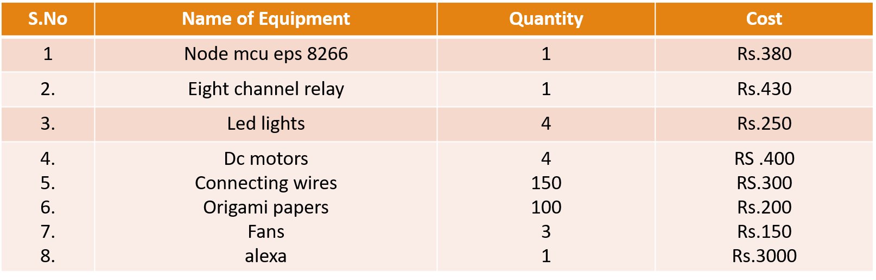

**RESULTS:**

The main aim of the project was to design a system in such a way that it can yield maximum output with minimum complexity and this home automation system successfully delivered it.

There are some issue that arises when using this system. The problems are the pronunciation of the user when doing the process. For the pronunciation matter, the system takes it at a quite high level of sensitivity. . So when the user wishes to use the system, thus he or she must produce the word with the correct pronunciation as in the training process

**Photos of the project**

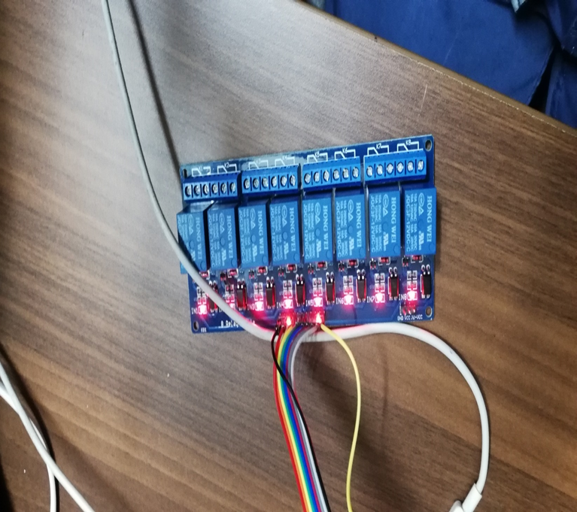

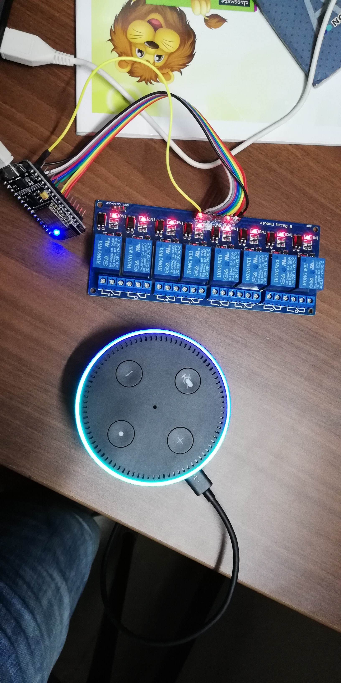

**FUTURE SCOPE:**

* 1. We are trying to keep relay in main current board so that the total set up would not be seen .

2. Only alexa will be visible so that it can be easily used and we can command it by our voice

3. The voice range is 10 to 15 m.

4. Since only alexa is visible the other people who sees it feels like the fans and lights are automated

**Service used for this project**

To use alexa we need take the help of alexa skill kit services.so we took skillkit called sinric.

This sinric is the mediater between node mcu and alexa.when we give camand to alexa it sends to sinric skill kit service the it gives action to node mcu then it makes devices to turn on and off.

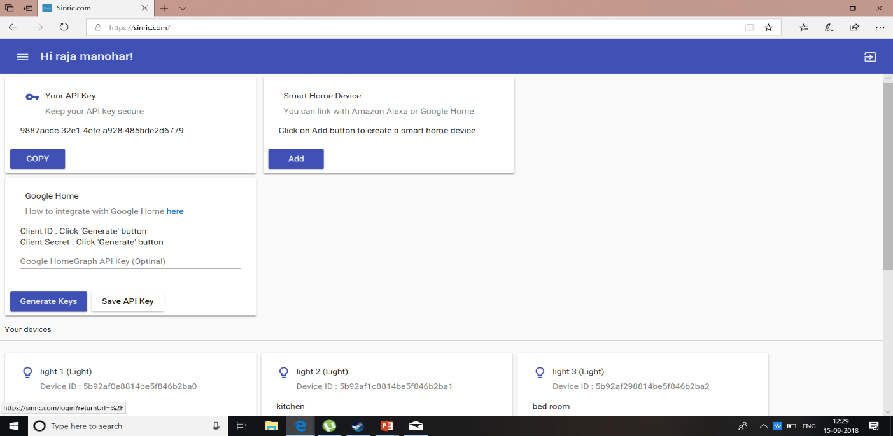

**REFERENCES:**

1. https://www.hackster.io/mayooghgirish/amazon-alexa-smart-home-using-nodemcu-b8ab4a

* 2.Wikipedia
* 
* 3.youtube



**CODE:-**

#include <Arduino.h>

#include <ESP8266WiFi.h>

#include <ESP8266WiFiMulti.h>

#include <WebSocketsClient.h> // https://github.com/kakopappa/sinric/wiki/How-to-add-dependency-libraries

#include <ArduinoJson.h> // https://github.com/kakopappa/sinric/wiki/How-to-add-dependency-libraries

#include <StreamString.h>

int device_1 = 16;

int device_2 = 4;

int device_3 = 0;

int device_4 = 2;

ESP8266WiFiMulti WiFiMulti;

WebSocketsClient webSocket;

WiFiClient client;

#define MyApiKey "9887acdc-32e1-4efe-a928-485bde2d6779" // TODO: Change to your sinric API Key. Your API Key is displayed on sinric.com dashboard

#define MySSID "raja1" // TODO: Change to your Wifi network SSID

#define MyWifiPassword "rajamanohar" // TODO: Change to your Wifi network password

#define HEARTBEAT_INTERVAL 300000 // 5 Minutes

uint64_t heartbeatTimestamp = 0;

bool isConnected = false;

void setPowerStateOnServer(String deviceId, String value);

void setTargetTemperatureOnServer(String deviceId, String value, String scale);

// deviceId is the ID assgined to your smart-home-device in sinric.com dashboard. Copy it from dashboard and paste it here

void turnOn(String deviceId) {

if (deviceId == "5be856f024cc9b14ac6a013c") // Device ID of first device

{

Serial.print("Turn on device id: ");

Serial.println(deviceId);

digitalWrite(device_1, HIGH);

}

else if (deviceId == "5be856ff24cc9b14ac6a013d") // Device ID of second device

{

Serial.print("Turn on device id: ");

Serial.println(deviceId);

digitalWrite(device_2, HIGH);

}

else if (deviceId == "5be8571424cc9b14ac6a013e") // Device ID of THIRD device

{

Serial.print("Turn on device id: ");

Serial.println(deviceId);

digitalWrite(device_3, HIGH);

}

else if (deviceId == "5be8572324cc9b14ac6a013f") // Device ID of FOURTH device

{

Serial.print("Turn on device id: ");

Serial.println(deviceId);

digitalWrite(device_4, HIGH);

}

else {

Serial.print("Turn on for unknown device id: ");

Serial.println(deviceId);

}

}

void turnOff(String deviceId) {

if (deviceId == "5be856f024cc9b14ac6a013c") // Device ID of first device

{

Serial.print("Turn off Device ID: ");

Serial.println(deviceId);

digitalWrite(device_1, LOW);

}

else if (deviceId == "5be856ff24cc9b14ac6a013d") // Device ID of second device

{

Serial.print("Turn off Device ID: ");

Serial.println(deviceId);

digitalWrite(device_2, LOW);

}

else if (deviceId == "5be8571424cc9b14ac6a013e") // Device ID of THIRD device

{

Serial.print("Turn off Device ID: ");

Serial.println(deviceId);

digitalWrite(device_3, LOW);

}

else if (deviceId == "5be8572324cc9b14ac6a013f") // Device ID of FOURTH device

{

Serial.print("Turn off Device ID: ");

Serial.println(deviceId);

digitalWrite(device_4, LOW);

}

else {

Serial.print("Turn off for unknown device id: ");

Serial.println(deviceId);

}

}

void webSocketEvent(WStype_t type, uint8_t * payload, size_t length) {

switch(type) {

case WStype_DISCONNECTED:

isConnected = false;

Serial.printf("[WSc] Webservice disconnected from sinric.com!\n");

break;

case WStype_CONNECTED: {

isConnected = true;

Serial.printf("[WSc] Service connected to sinric.com at url: %s\n", payload);

Serial.printf("Waiting for commands from sinric.com ...\n");

}

break;

case WStype_TEXT: {

Serial.printf("[WSc] get text: %s\n", payload);

// Example payloads

// For Switch or Light device types

// {"deviceId": xxxx, "action": "setPowerState", value: "off"} // https://developer.amazon.com/docs/device-apis/alexa-powercontroller.html

// For Light device type

// Look at the light example in github

DynamicJsonBuffer jsonBuffer;

JsonObject& json = jsonBuffer.parseObject((char*)payload);

String deviceId = json ["deviceId"];

String action = json ["action"];

if(action == "setPowerState") {

Serial.print(action);// Switch or Light

String value = json ["value"];

if(value == "ON") {

turnOn(deviceId);

} else {

turnOff(deviceId);

}

}

else if (action == "SetTargetTemperature") {

String deviceId = json ["deviceId"];

String action = json ["action"];

String value = json ["value"];

}

else if (action == "test") {

Serial.println("[WSc] received test command from sinric.com");

}

}

break;

case WStype_BIN:

Serial.printf("[WSc] get binary length: %u\n", length);

break;

}

}

void setup() {

Serial.begin(115200);

pinMode(device_1, OUTPUT);

pinMode(device_2, OUTPUT);

pinMode(device_3, OUTPUT);

pinMode(device_4, OUTPUT);

WiFiMulti.addAP(MySSID, MyWifiPassword);

Serial.println();

Serial.print("Connecting to Wifi: ");

Serial.println(MySSID);

// Waiting for Wifi connect

while(WiFiMulti.run() != WL_CONNECTED) {

delay(500);

Serial.print(".");

}

if(WiFiMulti.run() == WL_CONNECTED) {

Serial.println("");

Serial.print("WiFi connected. ");

Serial.print("IP address: ");

Serial.println(WiFi.localIP());

}

// server address, port and URL

webSocket.begin("iot.sinric.com", 80, "/");

// event handler

webSocket.onEvent(webSocketEvent);

webSocket.setAuthorization("apikey", MyApiKey);

// try again every 5000ms if connection has failed

webSocket.setReconnectInterval(5000); // If you see 'class WebSocketsClient' has no member named 'setReconnectInterval' error update arduinoWebSockets

digitalWrite(device_1,LOW);

digitalWrite(device_2,LOW);

digitalWrite(device_3,LOW);

digitalWrite(device_4,LOW);

turnOff("5be856f024cc9b14ac6a013c");

turnOff("5be856f024cc9b14ac6a013d");

turnOff("5be856f024cc9b14ac6a013e");

turnOff("5be856f024cc9b14ac6a013cf");

}

void loop() {

webSocket.loop();

if(isConnected) {

uint64_t now = millis();

// Send heartbeat in order to avoid disconnections during ISP resetting IPs over night. Thanks @MacSass

if((now - heartbeatTimestamp) > HEARTBEAT_INTERVAL) {

heartbeatTimestamp = now;

webSocket.sendTXT("H");

}

}

}

// If you are going to use a push button to on/off the switch manually, use this function to update the status on the server

// so it will reflect on Alexa app.

// eg: setPowerStateOnServer("deviceid", "ON")

void setPowerStateOnServer(String deviceId, String value) {

DynamicJsonBuffer jsonBuffer;

JsonObject& root = jsonBuffer.createObject();

root["deviceId"] = deviceId;

root["action"] = "setPowerState";

root["value"] = value;

StreamString databuf;

root.printTo(databuf);

webSocket.sendTXT(databuf);

}

//eg: setPowerStateOnServer("deviceid", "CELSIUS", "25.0")

void setTargetTemperatureOnServer(String deviceId, String value, String scale) {

DynamicJsonBuffer jsonBuffer;

JsonObject& root = jsonBuffer.createObject();

root["action"] = "SetTargetTemperature";

root["deviceId"] = deviceId;

JsonObject& valueObj = root.createNestedObject("value");

JsonObject& targetSetpoint = valueObj.createNestedObject("targetSetpoint");

targetSetpoint["value"] = value;

targetSetpoint["scale"] = scale;

StreamString databuf;

root.printTo(databuf);

webSocket.sendTXT(databuf);

}

**THANK YOU**